Document Properties
Document Title | Blazar Architecture
Task number | 4.2.3
Responsible | François Rossigneux
Author(s) / contributor(s) | Jean-Patrick Gelas  Laurent Lefèvre  François Rossigneux
Document Status | Final
Version | Revision n°1

Summary
The main task was to design a resource reservation service with a scheduling algorithm taking into account the efficiency of each host and managing their standby modes.
Blazar, a resource reservation service, allows the user to book physical machines in order to guarantee a mono-tenancy environment with homogeneous performances suitable for HPC applications. The compute nodes are allocated in an efficient way, taking into account their efficiency, and turned off when they are unused.
The efficiency metric is a mix of the power consumption, collected with Kwapi, and the performance index given by an Unix bench. Each new machine added in the cloud is benchmarked, as for identical CPU, the power consumption may vary up to 20% depending of the manufacturing hazards.

Keywords
reservation, ranking, standby, efficiency




Resource Reservation
Architecture
Sommaire
1 Introduction 4
1.1 Purpose 4
1.2 Scope 4
2 Architecture Overview 5
3 Blazar 6
3.1 Introduction 6
3.2 Architecture 6
3.3 Compute host reservation 7
3.4 Specific API 7
3.5 Hardware requirements syntax 8
3.6 Documentation 8
3.7 Code repositories 8
4 Kwranking 9
4.1 Installation 9
4.2 Configuration file 9
4.3 API 9
4.4 Documentation 10
4.5 Code repositories 10
5 Kwstandby 11
5.1 Installation 11
5.2 Configuration file 11
5.3 API 11
5.4 Documentation 12
5.5 Code repositories 12

Introduction

Purpose
This software design specification provides an overview of design and architecture of the proposed resource management framework for XLcloud project.

Scope
OpenStack virtual machines scheduling doesn't take into account the energy efficiency criteria. We created a resource reservation service with a scheduling algorithm taking into account the efficiency of each host and managing their standby modes.

Architecture Overview
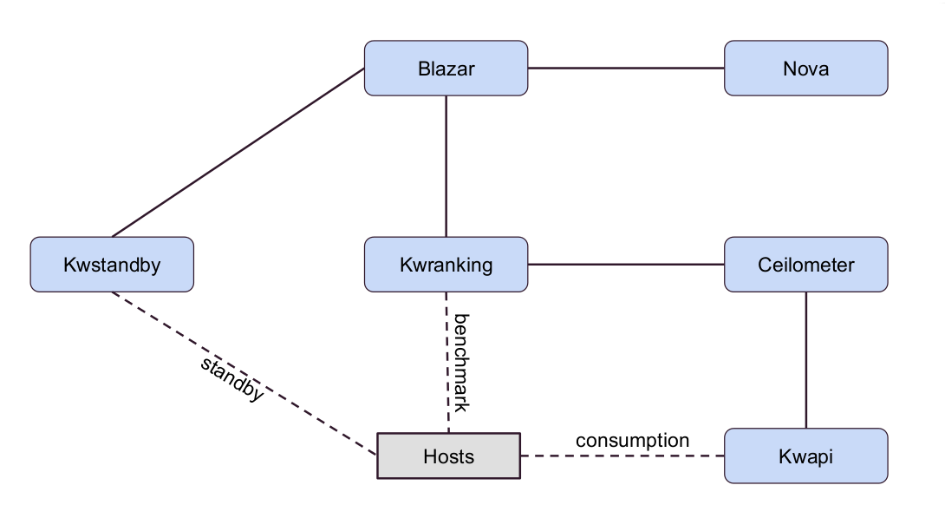
Global Architecture

The proposed architecture includes Blazar, Kwranking and Kwstandby. It depends on Kwapi, Ceilometer and Nova, which have been described in the previous specification.
Roles of the modules:
- Kwapi: takes the power measurements
- Ceilometer: stores the power measurements
- Blazar: manages the resources
- Kwranking: benchmarks the machines
- Kwstandby: wakes up and turns of the machines

Blazar

Introduction
Blazar allows the reservation of physical and virtual resources (physical hosts, instances, network and volumes).
In terms of benefits added, it will:
- improve visibility of cloud resources consumption (current and planned for future);
- enable cloud resource planning based on current and future demand from end users;
- automate the processes of resource allocation and reclaiming;
- provide energy efficiency for physical hosts (both compute and storage ones);
- potentially provide leases as billable items for which customers can be charged a flat fee or a premium price depending on amount of reserved cloud resources and their usage

Architecture
Is is composed of the following modules:
- Climate-client: provides the opportunity to communicate with Blazar via REST API (climate-api service).
- Climate-api: waits for the REST calls from the outside world to redirect them to the manager. climate-api communicates with climate-manager via RPC. Runs as a separated process.
- Climate-manager: implements all logic and operations with leases, reservations and events. Communicates with Blazar DB and stores there data structure of connected leases, reservations (both physical and virtual) and events. climate-manager service is responsible for running events created for lease and process all actions that should be done this moment. Manager uses resource-plugins to work with concrete resources (instances, volumes, compute hosts). climate-manager uses Keystone trusts to commit actions on behalf of user who has created lease before.
- Resource-plugin: responsible for exact actions to do with reserved resources (VMs, volumes, etc.) When working knows only about resource ID and token to use. All resource plugins work in the same process as climate-manager.
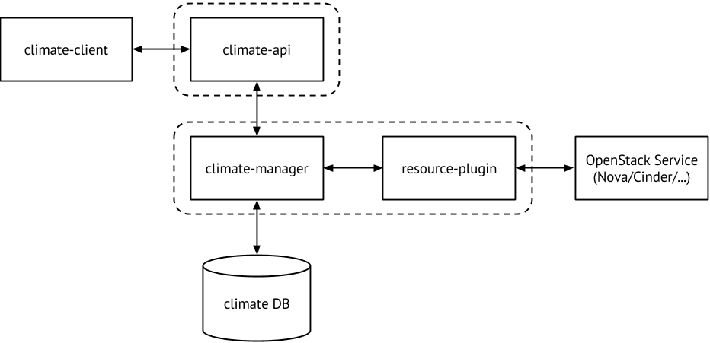
Blazar Architecture

Compute host reservation
Compute hosts reserving contains two steps:
- Admin marks hosts from common pool as possible to be reserved. That is implemented by moving these hosts to special aggregate named freepool.
- User asks for reserving of host with specified characteristics like:
  - the region
  - the availability zone
  - the host capabilities extra specs (scoped and non-scoped format should be accepted)
  - the number of CPU cores
  - the amount of free RAM
  - the amount of free disk space
  - the number of hosts
Resource here will be new aggregate containing reserved hosts. The time lease starts, user may use reserved compute capacity to run his/her instances on it passing special scheduler hint to Nova. When host is reserved, it’s not used for usual instance running, it might be used only when lease starts and only by passing reservation ID to Nova.
Blazar supports immediate reservation and in advance reservation.
The eligible hosts are sorted by efficiency, by contacting Kwranking. The reservations are regularly optimized to use always the most efficient hosts and save energy without performance loss. The unused hosts are put in standby modes if there is no new leases on them in the next minutes.

Installation
Clone the Blazar git repository to the management server:
git clone https://github.com/stackforge/blazar

As a user with root permissions or sudo privileges, run the Kwranking installer and copy the configuration files:
$ pip install blazar
$ cp -r blazar/etc/ blazar /etc/
Start the Blazar services:
$ blazar-api
$ blazar-manager

Configuration file
The configuration file is located in /etc/blazar/blazar.conf.
The manager section defines the supported reservation plugins:
Option | Default value | Note
plugins | physical.host.plugin | Enable physical host reservation

The physical:host section defines the specific options for physical host reservation:
Option | Default value | Note
on_start | on_start | Method to trigger when a lease starts
on_end | on_end | Method to trigger when a lease ends
climate_username | climate | Used for contacting Kwranking and Kwstandby
climate_password | password | Used for contacting Kwranking and Kwstandby
climate_tenant_name | service | Used for contacting Kwranking and Kwstandby

Specific API
Host management:
Verb | URL | Parameters | Expected result
GET | /v1/os-hosts/ |  | Returns all hosts details
GET | /v1/os-hosts/<host> | host | Returns the host details
PUT | /v1/os-hosts/<host> | host  {"values": { "foo": "bar"}} | Update the host values
POST | /v1/os-hosts | {  "name": "compute",  "values": {  "foo": "bar"  }  } | Add an host existing in Nova
DELETE | /v1/os-hosts/<host> | host | Delete an host

Reservation management:
Verb | URL | Parameters | Expected result
GET | /v1/leases |  | Returns all leases details
GET | /v1/leases/<id> | Lease id | Returns the lease details
POST | /v1/leases | {  "name": a,  "start_date": b,  "end_date": c,  "reservations": [  {  "min": d,  "max": e,  "resource_type": "physical:host",  "resource_properties": f,  "hypervisor_properties": ""  }  ]  }  a = lease name  b = start date "AAAA-MM-JJ HH:MM"  c = end date "AAAA-MM-JJ HH:MM"  d = min host requested  e = max host requested  f = resource properties using the Nova JsonFilter syntax | Creates a physical lease
POST | /v1/leases | {  "name": a  }  a = lease name | Update the lease name
DELETE | /v1/leases/<id> | Lease id | Delete the lease if it is not yet started

Hardware requirements syntax
The hardware requirements syntax is similar to the Nova JsonFilter syntax.
It provides the opportunity to write complicated queries for the hosts capabilities filtering, based on simple JSON-like syntax. There can be used the following operations for the host states properties: =, <, >, in, <=, >=, that can be combined with logical operations. For example, there is a query:
['and',
['=', '$vcpus', 4],
['>=', '$memory_mb', 4096]
]
The keys can be found by doing a request to /v1/os-hosts/.

Documentation
Documentation can be found at:
https://wiki.openstack.org/wiki/Blazar

Code repositories
https://github.com/stackforge/blazar
https://github.com/stackforge/python-blazarclient

Kwranking
Kwranking provides information about host efficiency.
It deploys UnixBench on remote hosts using SSH with public key authentication and runs arithmetic tests. The returned value is stored in the DB (it never changes over time). During the tests, the max power consumption is reached and stored in Ceilometer, so the flop/w metric is build using the max power value stored in Ceilometer and the flop value returned by the benchmark. The flop/w metric is updated periodically, because the max power consumption may vary over the machine lifetime. An API allows the user to find the most efficient hosts from a list of hosts passed as parameter.

Installation
Clone the Kwranking git repository to the management server:
git clone https://github.com/frossigneux/kwranking

As a user with root permissions or sudo privileges, run the Kwranking installer and copy the configuration files:
$ pip install kwranking
$ cp -r kwranking/etc/kwranking /etc/
Start the Kwranking API:
$ kwranking-api

Now add new hosts in kwranking using the API request /v1/hosts/set/. These hosts must be accessible using SSH with public key authenfication.

Configuration file
The configuration file is located in /etc/kwranking/kwranking.conf.
Option | Default value | Note
api_port | 5001 | API port
acl_enabled | true | Keystone authentication
policy_file | /etc/kwstandby/policy.json | Access rules
log_file | /var/log/kwranking.log | Log file
refresh_interval | 5184000 | Interval between two requests to Ceilometer to retrieve the max value
sql_type | mysql | SQL type
sql_server | localhost | SQL server
sql_port | 3306 | SQL port
sql_user | root | SQL user
sql_password | password | SQL password
sql_database | kwranking | SQL database

API
Verb | URL | Parameters | Expected result
GET | /v1/hosts/get-id/ |  | Returns all hosts IDs
GET | /v1/hosts/get/ |  | Returns all hosts details
GET | /v1/hosts/get/<host>/ | host | Returns the host details
POST | /v1/hosts/get-rank/ | {  "hosts": a,  "method": b,  "number": c  }  a = host list separated by “;”  b = ranking method (Efficiency or Flop or Wmax or Wmin)  c = number of hosts to return | Ranks the hosts passed as parameter
PUT | /v1/hosts/set/ | {  "host": a  }  a = the host to benchmark and add in the database | Returns the probe meter value

Documentation
Documentation can be found at:
http://kwranking.readthedocs.org

Code repositories
https://github.com/frossigneux/kwranking
https://github.com/frossigneux/python-kwrankingclient

Kwstandby
Kwstandby provides a REST API to shutdown and wakeup the hosts using their IPMI cards.

Installation
Clone the Kwstandby git repository to the management server:
git clone https://github.com/frossigneux/kwstandby

As a user with root permissions or sudo privileges, run the Kwranking installer and copy the configuration files:
$ pip install kwstandby
$ cp -r kwstandby/etc/kwstandby /etc/
Start the Kwranking API:
$ kwstandby-api

Configuration file
The configuration file is located in /etc/kwstandby/kwstandby.conf.
Option | Default value | Note
api_port | 5002 | API port
acl_enabled | true | Keystone authentication
policy_file | /etc/kwstandby/policy.json | Access rules
log_file | /var/log/kwstandby.log | Log file
ipmi_node | {'interface':'lanplus', 'host':'192.168.0.2', 'username':'user1', 'password':'secret1'} | IPMI card information  Multiple lines are allowed

Keystone authtoken section :
Option | Default value | Note
auth_node | localhost | Auth node
auth_protocol | http | Protocol
admin_user | kwstandby | User
admin_password | password | Password
admin_tenant_name | service | Tenant

API
Verb | URL | Parameters | Expected result
GET | /v1/status/<host> | host | Returns the host status
GET | /v1/status/ |  | Returns all the host status
PUT | /v1/status/<host> | host  {  "status": “standby” or “wakeup”  } | Update the node status

Documentation
Documentation can be found at:
http://kwstandby.readthedocs.org

Code repositories
https://github.com/frossigneux/kwstandby
https://github.com/frossigneux/python-kwstandbyclient

